|  |  |  |
| --- | --- | --- |
| LEADING INDICATORS | LAGGING INDICATORS | COINCIDENTAL INDICATORS |
|  |  |  |
| Purchasing Managers’ Index | The average duration of unemployment |  |
| Durable Goods Orders | The ratio of manufacturing and trade inventories to sales |  |
| Consumer Confidence Index | The change in labor cost per unit of output in manufacturing |  |
| Jobless Claims | The average prime rate charged by banks |  |
| Yield Curve | The real (inflation-adjusted) dollar volume of outstanding commercial and industrial loans. |  |
| Company Performance | The ratio of consumer installment credit outstanding to personal income |  |
|  | The change in the Consumer Price Index for services, |  |
|  |  |  |
|  |  |  |
|  |  |  |
|  |  |  |
|  |  |  |

Relationships:

10 years treasury bonds influence the direction of mortgage interest rates.

Extract from LinkedIn comments on Chris Porter post: “Desirability, quality of life and opportunity guided by differences in tax policy, cost of living, cost of housing, crime, job opportunities and weather. The NE and MidWest will always have horrible weather and the sunbelt belt states will continue to have better weather and often Republicans policies which are pro-job growth and pro-economic growth.”

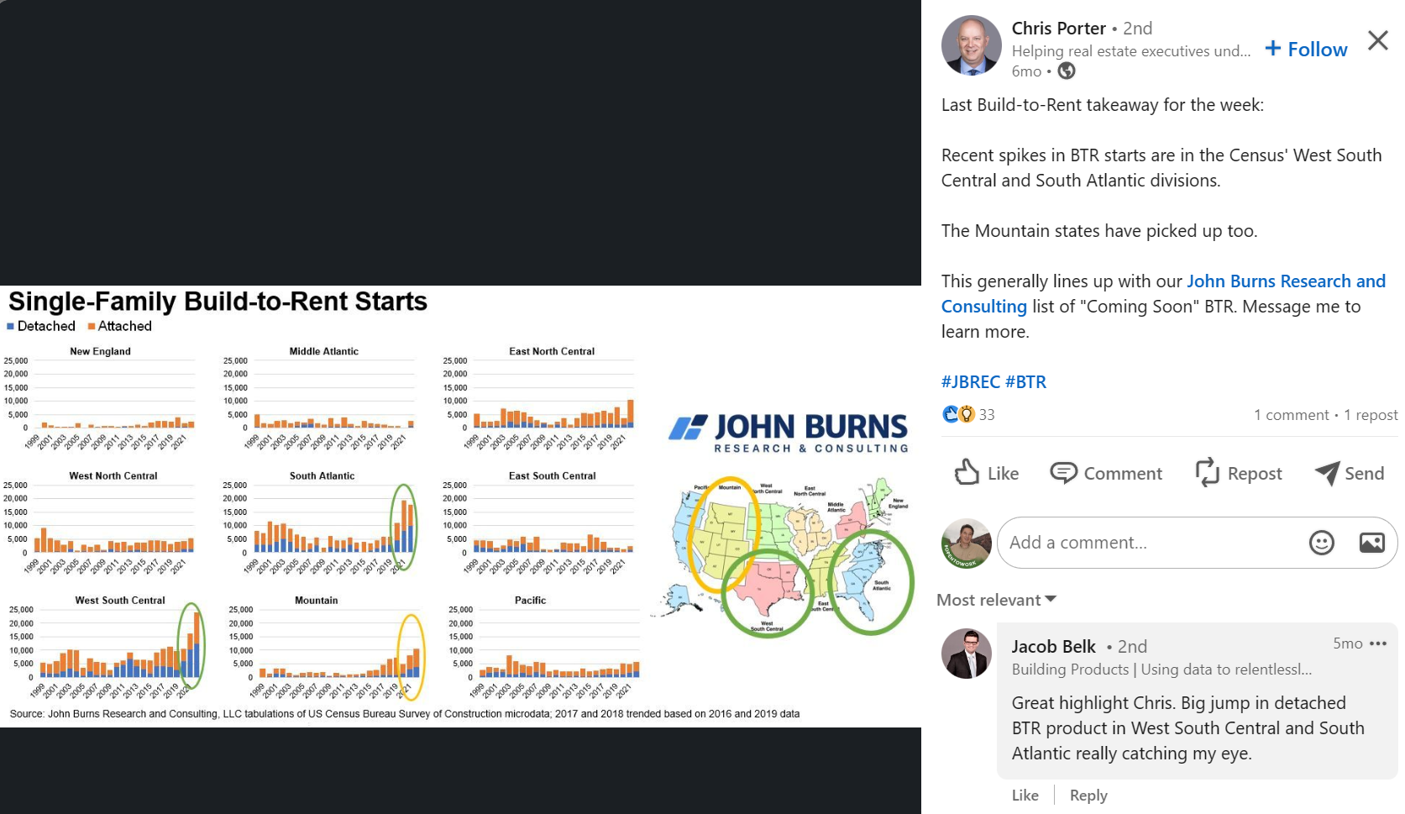

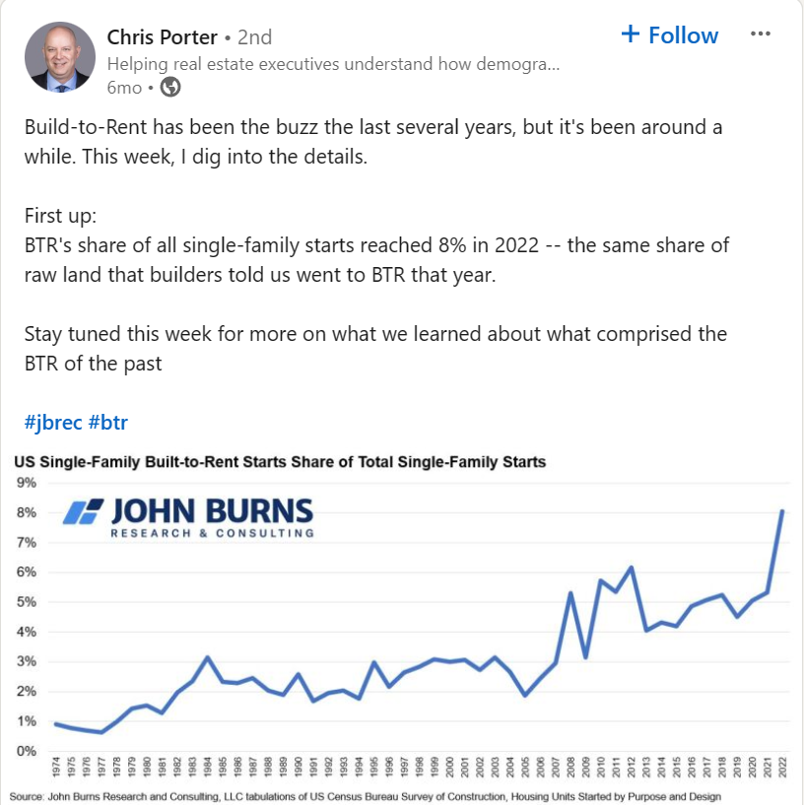

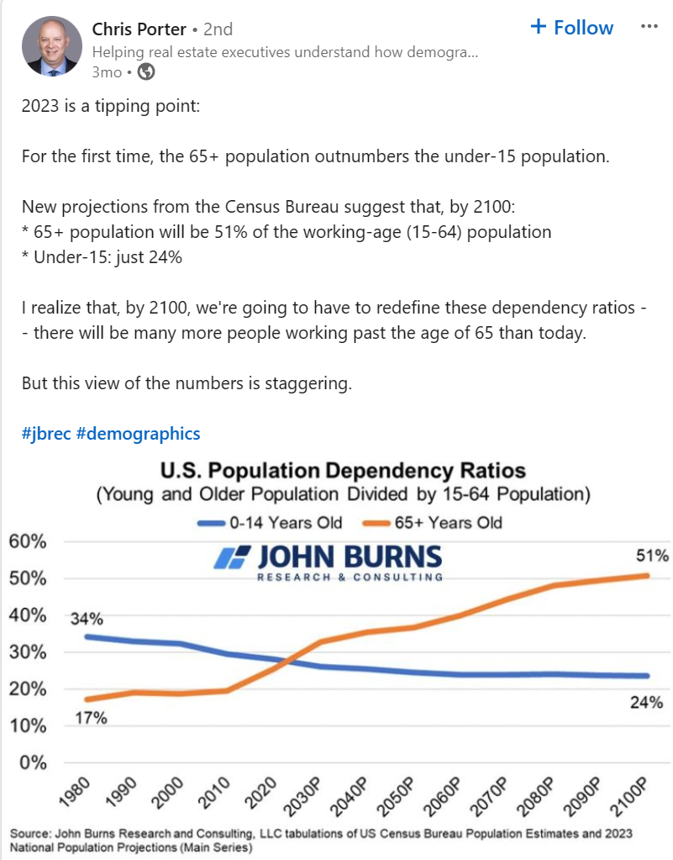

The post shows the ratio of older and young population to the working age population. Not the share of the overall. Here is the distribution by age. 15-64 is 65% of the population today, but declines over time.

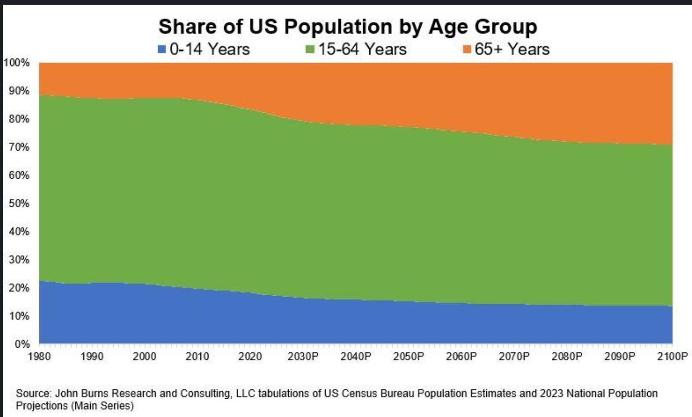

Build-to-Rent Takeaway #2:  
  
Before the recent boom, roughly 25K per year of SF BTR homes took place in small communities (fewer than 25 homes), and/or in rural areas.  
  
From 1999-2016, 23% of BTR was outside metro areas.  
  
Compare that to just 8% of SF homes built for sale.

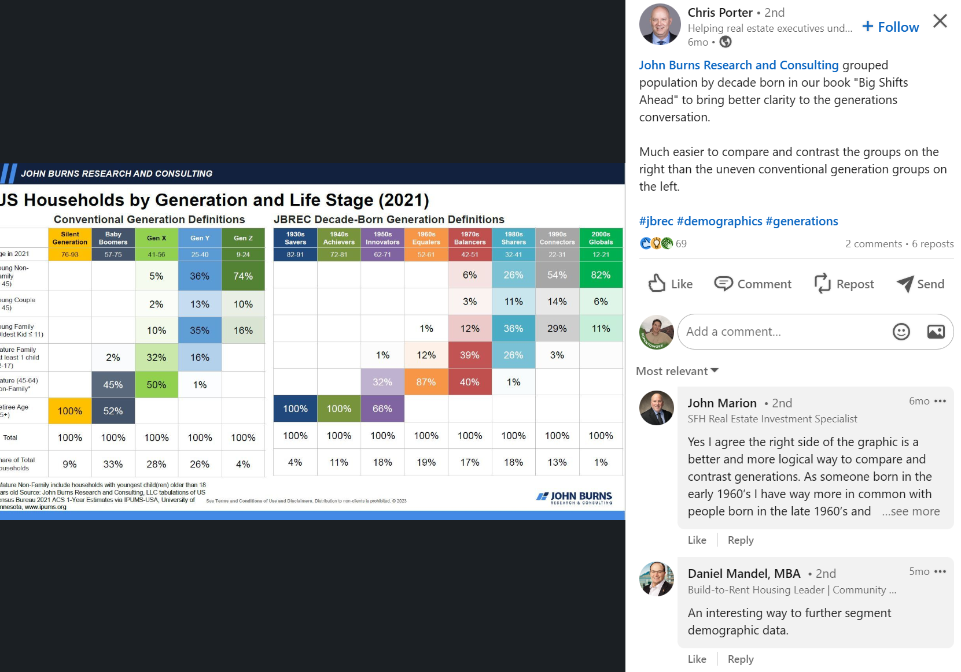

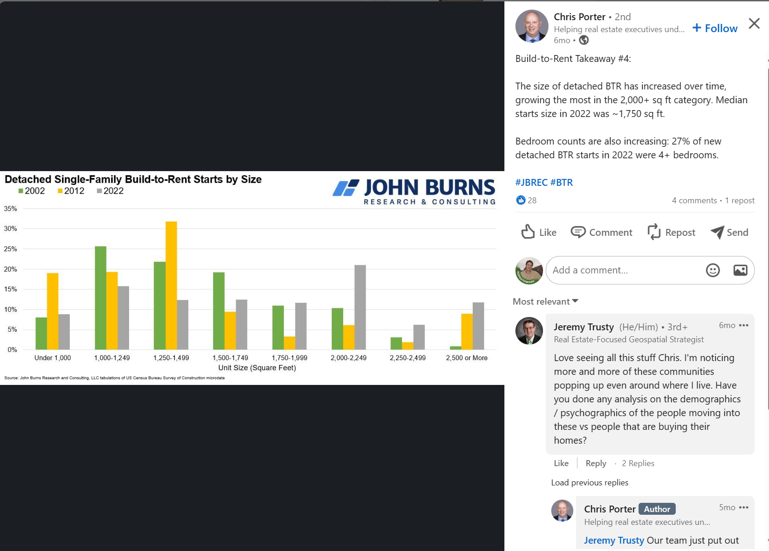

[The Light: 🔑🏠 4 Keys for Attracting Build-to-Rent Tenant (jbrec.com)](https://jbrec.com/insights/4-keys-for-attracting-build-to-rent-tenants/)

Ideas for Capstone 2

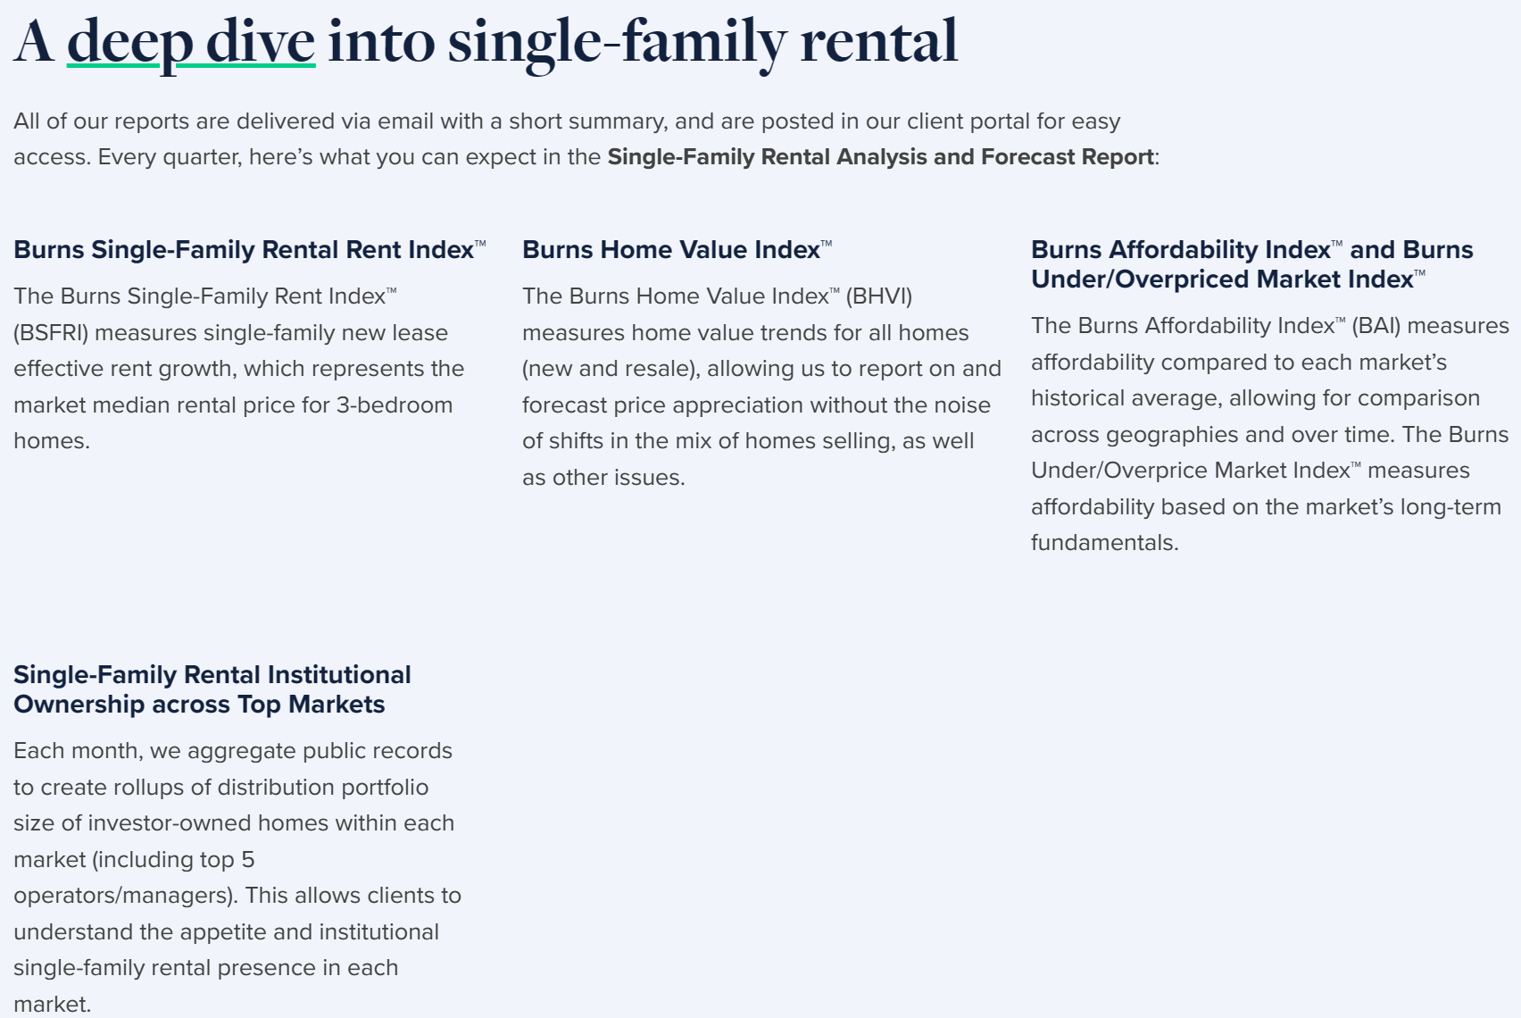

[Top 50 Master Plans Sold Over 34,000 New Homes in 2023 (jbrec.com)](https://jbrec.com/insights/top-50-master-plans-sold-34000-new-homes-in-2023/)

Idea for capstone: mortgage rates affects the sales volume

Data sets:

* mortgage rates or indirectly, 10 yrs bonds,
* house sales volume
* cpi index
* [Dear Consultant: How do you identify the best markets for apartment communities? (jbrec.com)](https://jbrec.com/insights/dear-consultant-identify-best-markets-for-apartment-communities/)

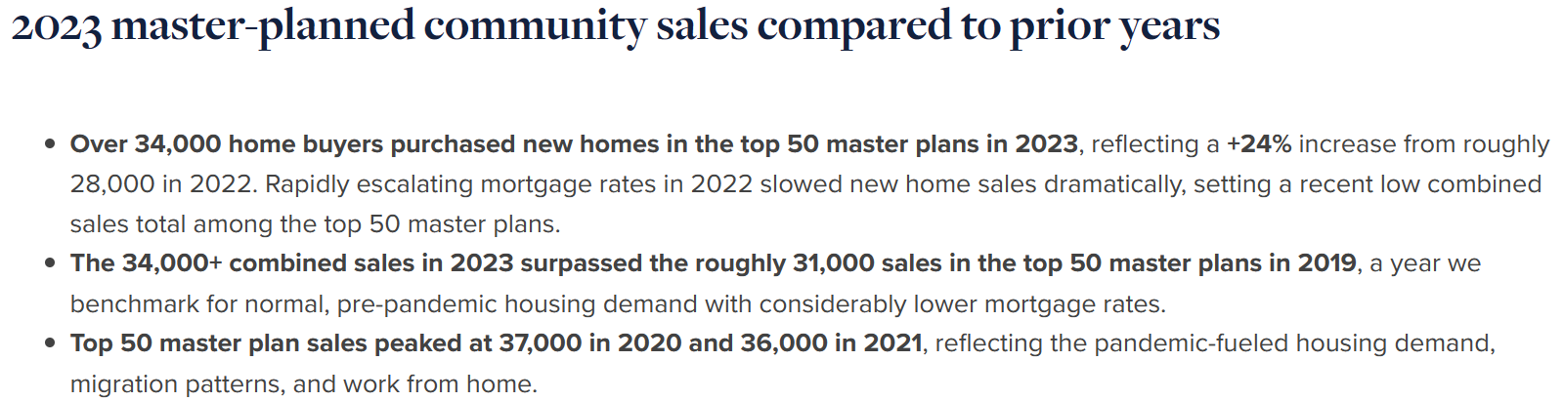  




Fed interest cycles that create recessions usually take about 12 months for the recession to play out. We’re now about 6 or 7 months in (as of Youtube post on 02/2023)

Mortgage interest rates affects the housing market volume of sales/rentals

42% of all national builders are publicly traded companies, so information is readily available

The other 58% John Burns got info through comments through their clients

Builders gross margin was about 20% before SG&A (Selling, General, and Administrative Expenses ), or about 10% pre tax of net income. That’s how they underwrite. Before Covid it was about 20%. then it shot up to 28%. They have access to loans with very good fixed rates that are not due for years so they keep building despite falling prices.

Feb 2022 was the peak of prices then by June prices were falling more than rising

Home builders dropped prices by 5% by July 2022 just to get some sales going, so they still have a 23% gross margin. Their balance sheet has never been stronger.

Private builders have strong balance sheet too but not as strong as publicly traded builders

Markets where it was overbuilt:

* Boise, Idaho (poster child for what can go wrong)
* Dallas, TX
* Houston, TX (has 900 actively selling communities right now)
* Austin, TX (m relied too much on affluent people coming from CA etc, tech jobs)

Undersupplied markets, where demand still flowing in:

* Florida. People moving from CA and North east

Blackstone is doing lease to own because people cant afford to buy

DR Horton have repurposed 115 ‘for sale’ communities to be for rent. They have over 1000 ‘for sale’ communities so that is huge chunk. They will sell as soon as lease is up, at huge margins, some like 40% margin of profit, double the normal.

Built to rent is new phenomenon. We have a 40 year high of apartments under construction right now.

BTR SFRs is 3% of total market and 10% when you include apartments. People want BTR SFR so premium is very high

CAP rates have come up but not as much, the cost of debt have come up about 1450, 200 basis points, which is large, but lenders have not raised their interest rates as much, they are just asking for more equity. (35-40% instead of 20-25$)

John Burns used to look at new permits vs new jobs in a particular area. Now they prodiced over 70 pages every month in more than 100 metro area.

Job dept ratios are pretty strong right now. Job market must be looked at on year to year basis because job market is cyclical so you got to compare July to July, August to August. Job growth is 5% now, but is misleading because is hospitality jobs that are driving numbers up

For first time in history nr of graduates from school = nr of people retiring. So where is the growth of labor come from?

John Burns is doing about 1000 consultant deals a year

After Covid, more 300,000 households were created than we thought during normal times. John Burns figured out to calculate migration trends, how often people are moving domestically, with only 2 months lag.

A million three households we expect in a typical year to form. During Covid it fell to 1 million, second year it went up to a million nine, now we’re back to 1.3 million over the last 12 months (youtube was posted June 2023) butn is trending down again. REITS report shows that number of adults per apartment is falling.

Baby boomer wealth effect: parents cosigning for their kids (a lot of tenants are getting help from their parents) to have more bedrooms so they can use it as offices etc.. The data John Burns wish to have: how many people are leasing apartments and their parents are co-signing. Interestingly, the rent to income ratio has not increased despite rents rising by 25% in the last three years. This can’t be possible without counting parental income.

The fact that home owners are locked into their homes not being able to sell because they have to preserve the low interest rates etc helps builders a lot because typically in a normal market aprox 12% of sales are new homes, now is 32%

The builders disclose on their earnings call how much incentives, hence hidden price reductions, have applied. Buying points etxc..

We are now short about 1.7 million homes and every year we need about 1.7 million homes to built

So we need to buold 2 million homes a year for many years to get rid of the deficit of homes

10 years ago, there was an equal number of debt and equity, about 9 trillions dollars of debt in houses and 9 trillions dollars in equity. Today we have 12 trillions in debt and 31 trillion in equity. Most people are not levered, in fact about a third of people don’t even have as mortgage (34 millions), primarily the baby boomers.

The Dod Frank regulation came in after 2008 and regulated lending

Warren Buffet owns Clayton properties, the 8th largest builder in USA. Builds 50,000 home a year

Jenny and Sarah are trusted people in John Burns close to John

John Burns has about 270 clients. Only clients have access to webinar, and approx. 2000 webinar attendees.

Podcasts are twice a month, called New Home Insights, with Dean Wehrli, Principal at JBREC. Another podcast is the light

Land Advisor Organization, Greg Vogel is CEO. Look for jobs here. They are based in Scottsdale AZ

[Land Advisors Organization Expertise](https://landadvisors.com/careers-2/)

Chris porter at JBREC is posting interesting income related data per regions on LinkedIn. Check him out

John Burns says you must learn Tableau to do dashboards

Hiring tips from john Burns: read the book “Who”

The CEO of radio flyer, The little red wagon company

John Burns says that post offices have valuable info that they don’t publish and is not aggregate it. i.e. change of addresses. They sell that data to marketing bu JBREC figured out how to aggregate it and that data only lags for a couple of months

Jiohn Burns is impressed about Parag Khanna and his website about climate change

[Climate Alpha - Parag Khanna](https://www.paragkhanna.com/climate-alpha/)

**New Privately-Owned Housing Units Authorized in Permit-Issuing Places: Total Units (PERMIT)**

[New Privately-Owned Housing Units Authorized in Permit-Issuing Places: Total Units (PERMIT) | FRED | St. Louis Fed (stlouisfed.org)](https://fred.stlouisfed.org/series/PERMIT)

